E-IPCR SYSTEM AS A TOOL FOR MANAGING EMPLOYEE PERFORMANCE EVALUATION USING SENTIMENT ANALYSIS

Researcher’s

Dela Cruz Joshua

Laguit Collins

Beltran Sherwin

Alberto, Kenneth Albert

**Table of Content**

**Chapter 1……………………………………………………………………… Page 3**

**Introduction……………………………………………………………………Page 3**

**Background of the Study…………………………………………………… Page 4**

**Objectives of the Study………………………………………………………. Page 5**

**Statement of the Problem……………………………………………………Page 5**

**Significance of the Study……………………………………………………... Page 6**

**Chapter 2………………………………………………………………………….. Page 8**

**Foreign Literature……………………………………………………………….. Page 12**

**Synthesis…………………………………………………………………………… Page 13**

**Conceptual of the Study……………………………………………………….. Page 15**

**Definition of terms………………………………………………………………..Page 16**

**Chapter 3…………………………………………………………………………… Page 18**

**Respondent of the Study……………………………………………………….Page 20**

**Data Gathering……………………………………………………………………Page 20**

**Statistical Tools…………………………………………………………………Page 21**

**Analytical Tools…………………………………………………………………Page 24**

**Reference………………………………………………………………………..Page 26**

**Chapter I**

**The Problem and Its Background**

This chapter presents the introduction, background of the study, objectives. Significance, scope and limitation of the study.

**Introduction**

The EULOGIO “AMANG” RODRIGUEZ INSTITUTE OF SCIENCE AND TECHNOLOGY (EARIST), as an educational system progressed from large decentralized structures to a more centralized one. Bringing services with utmost quality and dedication is one of the commitments of the institution while transforming into a system with high standards, efficient management and high faculty performance achievement. To sustain transformation, the university includes on its master plan strategies that support more efficient school management and performance evaluation systems. The Individual Performance Commitment and Review (IPCR) system is a vital part of the commitment to improving the performance of EARIST faculty. Accordingly, this shall set the internal policies and procedures in the implementation of Individual Performance Commitment and Review System in the University. It shall also serve as a foundation for achieving the goal to increase employee’s achievement and performance.

The Electronic Individual Performance Commitment and Review (e-IPCR) system developed, tested and implemented as a tool in managing faculty performance in EARIST served as an evaluation strategy for assessing individual collective performance within the university. The institution established a mechanism for setting standards to align individual objectives to agency department/college objectives.

**Background of the Study**

The need to establish an effective system that accurately evaluates the performance of its workers for the purpose of determining tenure, transfer or promotions, and appropriate incentives is seriously urgent or imperative to the public sector of the country. Hence, a performance appraisal system administered in such a manner as to continually foster the improvement of individual employee ‘s efficiency and organizational effectiveness had been continually introduced by the CSC.

Through the years, there have been a number of systems introduced by the CSC to establish an accurate and strategic measurement of performance. Notably, the CSC had issued policies on Performance Evaluation System (PES) requiring agencies including local government units to submit to the Commission their own versions of PES and to pilot-test its implementation. As part of the pilot-implementation process, the system was 6 evaluated through reports and feedback gathered from the LGUs prior to its final implementation. As a result, most officials and employees remain unfamiliar with the system as it is perceived to be too complex. In response to the feedback and meritorious demands of the LGUs, the Commission decided to defer the implementation of the revised policies on Performance Evaluation to give them more opportunity to design a system adapted to their organization needs. The LGU heads are given the discretion to, utilize the duly approved old Performance Evaluation System, or use the revised PES model designed and promulgated by the CSC corollary to the requirements of its policies on PES, or devise a Performance Evaluation System based on a combination of the old Performance Evaluation System and the revised Performance Evaluation System (CSC Memorandum Circular No.13 series of 1999).

**Objectives of the Study**

This study aims to develop a “E-IPCR System as a Tool for Managing Employee Performance Evaluation Using Sentiments Analysis to achieve the following objectives:

* Determine faculty accomplishment within the given period of time.
* Determine faculties evaluation sentiment remarks.
* Monitor the faculty's performance.
* Generate a summary report of evaluation results

**Development Tools**

* Frontend: React JS
* Backend: Node JS
* Database: MongoDB
* Web Hosting: Heroku

**Statement of the Problem**

The study is conducted to solve the problem that is bothering the faculty and evaluator in processing Individual Performance Commitment Review (IPCR).

The manual process of Individual Performance Commitment Review (IPCR) takes a lot of time. from generating the template, distribution of template, appending data, submission of evaluation, rating computation, sorting, retrieval and processing summary report. This problem has been going on for a very long time already. This manual process may even lead to data leaks, miss the submission target since the manual process of submission is through email. that is why the researcher proposed the “E-IPCR A system as a tool for managing employee performance evaluation using sentiment analysis that will solve the following problems”

**Significance of the Study**

This study can give feedback to the EULOGIO “AMANG” RODRIGUEZ INSTITUTE OF SCIENCE AND TECHNOLOGY (EARIST).

in the objective evaluation of the overall performance of its employees in order to improve the delivery of services to its respective constituents.

This study also aims to enrich or improve the performance appraisal system for the employees of the EULOGIO “AMANG” RODRIGUEZ INSTITUTE OF SCIENCE AND TECHNOLOGY (EARIST). unit, which could help in their effective administration.

**Scope and Limitation of the Study**

This study focuses on developing “E-IPCR a system as a tool for managing employee performance evaluation using sentiment analysis. to solve the current issue of Individual Performance Commitment Review (IPCR) which the whole process is manual including the submission.

This study only focuses on automating the current manual process of Individual Performance Commitment and Review (IPCT) on Eulogio Amang Rodriguez Institute of Science and Technology and only focuses on systems core concepts such as: Creation, Submission, validation, and generation of summary of evaluations. This study only covers the entire College of Arts and sciences as a dry run to determine if the “E-IPCR a system as a tool for managing employee performance evaluation using sentiment analysis” is effective.

**Chapter 2**

**Conceptual Framework**

This chapter consists of concepts, finished propositions, procedures and others.

Content of this chapter is used to adapt knowledge and data that is important in developing a new study.

**Review of the Related Literature**

This contains some of the related literature and studies that share relevance to the development of the system.

**E-IPCR**

Individual Performance Commitment and Review form (**IPCRF**) is an assessment tool used to rate government employees for their year’s accomplishments.

**Sentiment Analysis**

Studies the subjective information in an expression, that is the opinions, appraisals, emotions, or attitudes towards a topic, person or entity. Expressions can be classified as positive, negative, or neutral.

**Employee Performance**

Is defined as how an **employee** fulfills their **job** duties and executes their required tasks. It refers to the effectiveness, quality, and efficiency of their output. **Performance** also contributes to our assessment of how valuable an **employee** is to the organization.

**React JS**

According to (Wikipedia) react (also known as React.js or ReactJS) is an open-source front-end JavaScript library. For building user interfaces or UI components. It is maintained by Facebook and a community of individual developers and companies. React can be used as a base in the development of single-page or mobile applications. However, React is only concerned with state management and rendering that state to the DOM, so creating React applications usually requires the use of additional libraries for routing, as well as certain client-side functionality.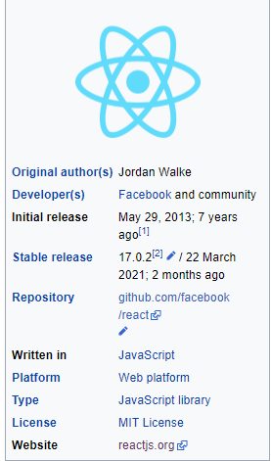

React was created by Jordan Walke, a software engineer at Facebook, who released an early prototype of React called “FaxJS”. He was influenced by XHF, an HTML component library for PHP.

**Node JS**

According to (Wikipedia) Node.js is an open-source, cross platform, back-end JavaScript runtime environment that runs on the V8 engine and executes JavaScript code outside a web browser. Node.js let developers use JavaScript to write command line tools and for server-side scripting ---- running scripts server-side to produce dynamic web page content before the page is sent to the user’s web browser. Consequently, Node.js represents a “JavaScript everywhere” paradigm. Unifying web-application development around a single programming language, rather than different languages for server-side and client-side script.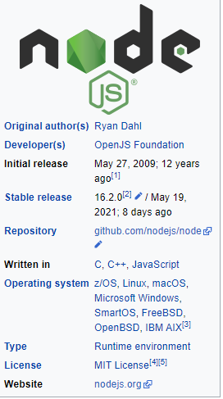

Node.js was written initially by Ryan Dahl in 2009, about thirteen years after the introduction of the first server-side JavaScript environment, Netscape’s LiveWire Pro Web. The initial release supported only Linux and Mac OS X. It’s development and maintenance were led by Dahl and later sponsored by Joyent.

**MongoDB**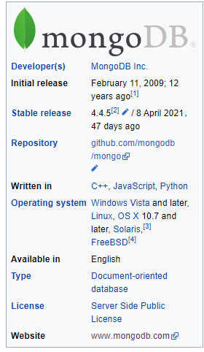

According to (Wikipedia) MongoDB is a source-available cross-platform document-oriented database program. Classified as a NoSQL database program, MongoDB uses JSON-like documents with optional schemas. MongoDB is developed by MongoDB Inc. and licensed under the Server-Side Public License (SSPL).

**Database Management System**

According to James A. Starkey (2010). A multi-user, a multi-user , elastic, on-demand, distributed relational database management system. The database is fragmented into distributed objects called atoms. Any change to a copy of an atom at one location is replicated to all other locations containing a copy of that atom. Transactional managers operate to satisfy the properties of atomicity, consistency, isolation and durability (James A. Starkey)

**Heroku** 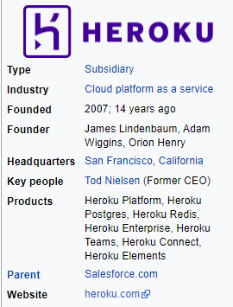

According to (Wikipedia) Heroku is a cloud platform as a service (PaaS) supporting several programming languages. One of the first cloud platforms, Heroku has been in development since June 2007, when it supported only the Ruby programming language, but now supports Java, Node.js, Scala, Clojure, Python, PHP, and Go. For this reason, Heroku is said to be a polyglot platform as it has features for a developer to build, run and scale applications in a similar manner across most languages.

**Foreign Literature**

Connelly and Goldman state, "initially transformational leadership was viewed as a personal quality or ability to inspire employees to look beyond self-interest and focus on organizational goals" (as cited in Lashway 2009). However, as leadership theories have continued to be researched another form of transformational leadership has evolved termed "Facilitative Leadership". Facilitative leadership is defined as "the behaviors that enhance the collective ability of a school to adapt, solve problems, and improve performance" (Connely & Goldman, 2010). In this style, the facilitator's role is to foster the involvement of employees at all levels. In other words, a leader should create a school culture that promotes collaboration, involvement, and empowerment of teachers and the school community. In contrast, any form of leadership that focuses on manipulating teachers and school culture to reach a personal vision or agenda will only create a climate and culture that detracts from the district's vision. (Stolp, 2009)

According to (Coleman, & Boorman 2005) Contextual performance is a kind of attitude like volunteering for extra work, helping others in solving difficult task, upholding enthusiasm at work, cooperating with others at the time of need, sharing critical resources and information for organizational development, abiding by the rules and regulations, and supporting organizational decisions for a better change.

This kind of behavior contributes to creating a stimulating culture and climate of the organization which aids in achieving individual productivity and organizational effectiveness. For selecting and inducting the right personnel in organizations, introducing personality tests and group discussion for measuring a prospective candidate’s ability for contextual performance along with the efficiency test.

**Synthesis**

Synthesis The summary of all the related literature is that universities have the same problems before they come up with a new system. The problems are the manual processes needed to be done are time consuming, the difficulty in handling and managing of records, the resources allotted for the reproduction of the evaluation forms were quite expensive and the reports were not submitted on time. The researcher will develop a paperless system in which the evaluator (students, faculty, and dean) will use the computer and the system to evaluate the teacher. The system will provide a list of faculty members where the research coordinator is the one who’s going to conduct an evaluation in the laboratory where the students will evaluate the faculty members. The new system is better because confidentiality is maintained. As soon as the evaluators finish with the evaluation, the information they have encoded will be sent to a database and not everyone can view the over-all results. This paperless system helps lessen the time intended in doing all the manual processes involved, provides easy handling, recording and retrieval of records, reduces the resources allotted for the multiple copies of the evaluation form and speeds up the production of summary results and the reports to be distributed. The researcher’s intended to develop a system for the human resource department to help the manual process in evaluating the faculty members every semester. The features are: system will then be given a username and a password to be able to log in to the system, provide a list of faculty members where the research coordinator is the one who’s going to conduct an evaluation, the ratings that have been encoded will be sent to a database, research coordinator have the right to access the settings in which it includes the search, create, update, delete, view, and print bar**.**

**Conceptual Model of the Study**

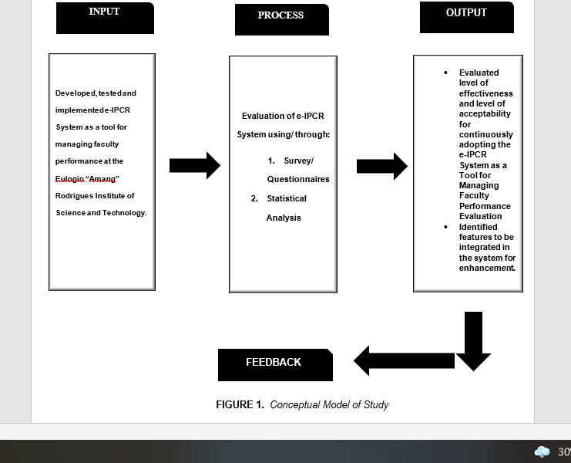

On the of forgoing concepts, theories and findings of related literature and studies presented, and insight taken from, a conceptual model was developed.

Based from the concepts, findings, related literatures, related studies, and ideas;

The conceptual model of the study was developed as shown in figure 1. This model shows and indicates the essential components required for the development of the system. The components include the input, process and output.

The **input** variables used in this study is the developed, tested and implemented e-IPCR System as a tool for managing faculty performance evaluation for EARIST.

The **process** variable is the evaluation of the system’s level of effectiveness and distribution and retrieval of survey questionnaires for data gathering and statistical analysis to obtain usable and useful information.

The **output** variable is the evaluated level of effectiveness and level of acceptability for continuously adopting the system as a tool for managing faculty performance evaluation and identifying what additional features have to be integrated in the system for more enhanced system.

**Feedback** from the respondents may be evaluated for future enhancement of the system.

**Definition of Terms**

To better understand the study, the following terms are operationally defined.

**Sentiment Analysis** Studies the subjective information in an expression, that is the opinions, appraisals, emotions, or attitudes towards a topic, person or entity. Expressions can be classified as positive, negative, or neutral.

**Employee -** An employeeis someone who gets paid to work for a person or company. Workers don't need to work full time to be considered employees—they simply need to be paid to work by an employer (the person or business that pays them).

**Performance -** happens when the performer is able to apply themselves to the task in front of them with the exact response required for the task, and within an environment that allows that response

**Evaluation -** To evaluate is defined as to judge the value or worth of someone or something. An example of evaluate is when a teacher reviews a paper in order to give it a grade. To draw conclusions from examining; to assess. It will take several years to evaluate the material gathered in the survey.

**E-IPCR** - The OPCR and IPCR use a table with similar columns such as: Major Final Outputs. Success Indicators. Actual Accomplishments. Rating for Quality (Q), Efficiency (E) and Timeliness (T) and the Average (Ave).

**Database -** is a systematic collection of data. They support electronic storage and manipulation of data. Databases make data management easy. Let us discuss a databaseexample: An online telephone directory uses a database to store data of people, phone numbers, and other contact details.

**Managing -** to handle or direct with a degree of skill: such as. a: to exercise executive, administrative, and supervisory direction of manage a business manage a bond issue manages a baseball team. b: to treat with care: husband managed his resources carefully.

**Joyent –** is a software and services company based in San Francisco, California. The company is a leading infrastructure-as-a-service company, specializing in cloud computing.

**Paradigm –** is a distinct set of concepts or through pattern, including theories, research method, postulates, and standard for what constitutes contribution to a field.

**Chapter 3**

**Research Methodology**

This chapter discusses the methods and data gathering tools in order to complete the study. The chapter also explains how the proposed web-based system is completed.

**Research Design**

**-**

**Methodology**

The Waterfalls Methodology is a tool to help one better understand the steps needed to do a quality evaluation, by following the process. There are (6) six steps of our Waterfalls methodology.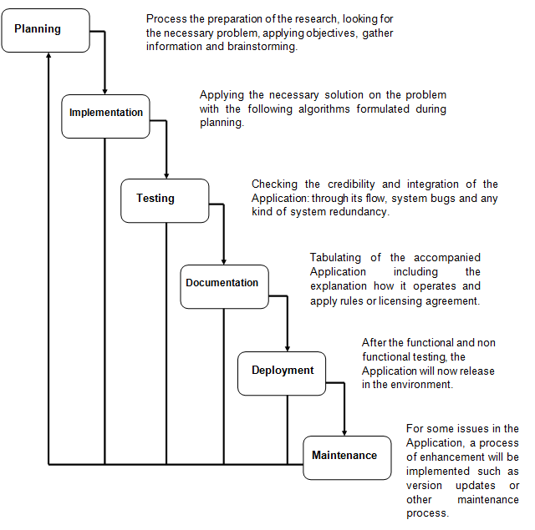

**Step 1.** **Planning**

* Process the preparation of the research. Looking for the necessary problem, applying objectives, gathering information and brainstorming.

**Step 2. Implementation**

* Applying the necessary solution to the problem with the following algorithms formulated during the brainstorming.

**Step 3. Testing**

* Checking the credibility and integration of the application. Through its flow system bugs and any kind of system redundancy.

**Step 4. Documentation**

* Tabulating of the accompanied applications including the explanations how it operates and applying rules or licensing agreement.

**Step 5. Deployment**

* After the functional and non-functional testing, the applicationwill now be released in the environment.

**Step 6. Maintenance**

* For some issues in the application a process of enhancement will be implemented such as version updates or other maintenance processes.

**Respondent of the Study**

The researcher was considered the Faculty Employee of the College of Arts and Science in Eulogio "Amang" Rodriguez Institute of Science and Technology, male and female. The respondents are chosen based on its efficiency to the researchers because being in the same college helps the researchers more on the testing phase of the proposed system as well as the surveys and Interviews.

**Data Gathering Instrumental and Techniques**

Gathering of data is necessary in this project study. Through careful investigation and data collection, the need for developing the proposed system was determined. Data gathering is important for it provides ideas on how to effectively, accurately, and successfully implement the proposed system. The proponent used questionnaire and observation as data gathering instruments. The proponent further observed on how the current system operates in order to serve the needs in developing the proposed system. The proponent also reviewed documents to determine the throughput of the current system in order to develop a better system.

**Questionnaire**. The questionnaire is suitable in this project study because it enables the proponent in the construction of generalizations. Contingent on the method of circulation, it can be rapidly done and information examination can begin immediately. Survey questionnaire maintains a strategic distance from bias that can affect the soundness and reliability of the data collated. The researcher’s use the questionnaire to verify the gathered problem from the observations of the researchers.

**Observations**. The observation method is suitable for this study. Observation is a data gathering method that does not interact with respondents and can rapidly be done. The researcher’s use observation methods to gather the existing problem.

**Preparation of Instruments**

The instrument used in this study to collect the data is a survey questionnaire. The researchers decided to use a survey questionnaire since it's faster than the other methods in terms of collecting data. Since the respondents of the study are the College of Arts and Sciences faculty, they can read and answer the questions with ease.

The researchers draft the survey questions based on the International Standardization Organization (ISO/IEC) 25010 systems and software quality requirements and evaluation in terms of its functional suitability, performance efficiency, compatibility, usability, reliability, security, maintainability, and portability.

**Statistical Tools**

In this study the researchers use the slovin's formula in getting the sample populations, as well as the weighted mean on calculating the survey results average to determine the result using 5 point based rating scale where the 5 being the highest and 1 is the lowest. The researchers also use a mean method to calculate the faculty accomplishments average based on Quality, Timeliness and Efficiency.

**Slovin’s Formula:**

slovin’s formula is used to calculate the sample size (n) given the population size (N) and a margin of error (e). It's a random sampling technique formula to estimate sampling size.

**Formula: n = N / (1+Ne2).**

whereas:

n = no. of samples

N = total population = 23

e = error margin / margin of error = 15% or 0.15

n = 23 / 1+ 23 * (0.15) ²

n = 23 / 1 + 23 * 0.0225

n = 23 / 1 + 0.5175

n = 23 / 1.5175

n = 15 faculty with 85% confidence level and 15% margin of error

**Weighted Mean’s Formula:**

The weighted arithmetic mean is similar to an ordinary arithmetic mean, except that instead of each of the data points contributing equally to the final average, some data points contribute more than others.

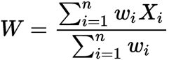

**W = weighted average**

**n = number of items to be averaged**

**Wi = weighted average * values**

**Xi = data values to be averaged**

**Mean Formula:**

There are several kinds of mean’s in mathematics, especially in statistics. For a data set, the arithmetic mean, also known as arithmetic average, is a central value of a finite set of numbers: specifically, the sum of the values divided by the number of values.

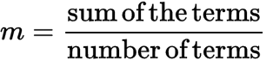

**Analytical Tools**

The researchers will use graphs such as: bar chart, pie chart etc. as analytical tools since graphs are the fastest and easiest way to visualize the data.

A bar chart or bar graph is a chart or graph that presents categorical data with rectangular bars with heights or lengths proportional to the values that they represent. The bars can be plotted vertically or horizontally. A vertical bar chart is sometimes called a column chart.

Pie charts can be used to show percentages of a whole, and represents percentages at a set point in time. Unlike bar graphs and line graphs, pie charts do not show changes over time.

**Context Diagram**

**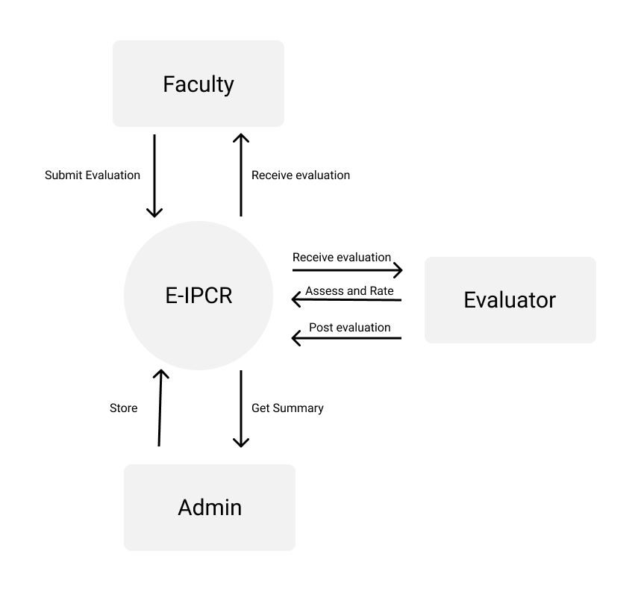***Figure 1.3 Context Diagram*

**Data Flow Diagram**

The researcher used a Level 0 Dfd that shows graphically the functions or the processes, which manipulate and store the distributed data between the system and its environment and between components of the proposed system.

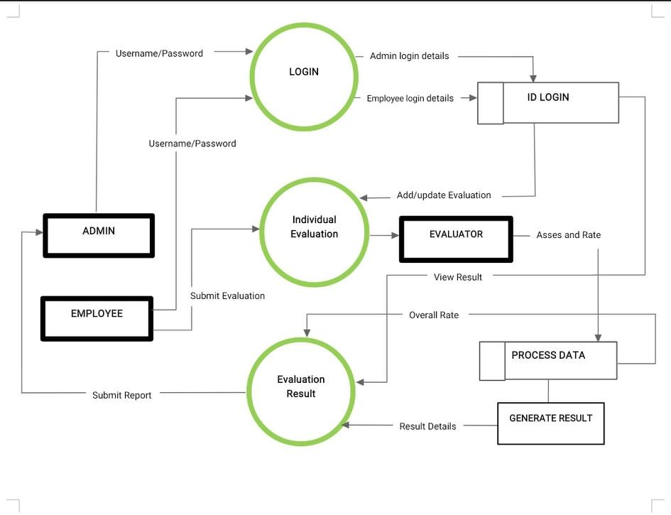

**Use Case Diagram**

In this diagram, the researchers represent the goal of the system and users by specifying the context of a system that should be viewed, and to provide a model for the flow of events when it comes to user interaction.

**Reference**

Grover, V., Leong, S.R., Segars, A.H. (1996): Information systems effectiveness: The construct, space and patterns of application. Information & Management 31 (4), 177 – 191

[5] Keil M, Beranek PM, Konsynski BR. Usefulness and ease of use: field study evidence regarding task considerations. Decis Support Syst. 1995; 13:75–91.

[6] Miller, Holmes (Spring 1996). "THE MULTIPLE DIMENSIONS OF INFORMATION QUALITY". Information Systems Management. 13 (2): 79–82

[7] Pearson, S.W. (1983). Development of a Tool for Measuring and Analyzing Computer User Satisfaction. Management Science, 29 (5), 530-545.

[8] Swartz, N. (2007). Data Management Problems Widespread: Organizations should regard data as their greatest asset and invest in data Management Accordingly. On the Edge: The Use & Misuse of Information). Retrieved from www.accessmylibrary.com

[9] Szajna B. Empirical evaluation of the revised Technology Acceptance Model. Manage Sci. 1996; 42:85–92.

[10] Petter, S., DeLone, W.H., McLean, E.R. (2008): Measuring information systems success: models, dimensions, measures, and interrelationships. European Journal of Information Systems 17 (3), 236 – 263